Cairo University Faculty of Computers and Information



**Advanced Software Engineering**

**Software design specification document**

**2020**

**Project Team**

|  |  |  |  |
| --- | --- | --- | --- |
| **ID** | **Name** | **Email** | **Mobile** |
| 20180075 | Tawfik Yasser Tawfik | tawfekyassertawfek@gmail.com | 01129348206 |
| 20180051 | Alamir Hassan Younis | alamirhassan8@gmail.com | 01127171631 |
| 20180279 | Mostafa adel mohamed | Mostafahutler6@gmail.com | 01005524395 |
| 20180229 | Muhammad Abdullah Aboud | maboud229@gmail.com | 01143837355 |

**[TA: Ahmed Samir]**

Contents

Class diagram design 3

Sequence diagram design 4

Github repository link 8

# 

# Class diagram design

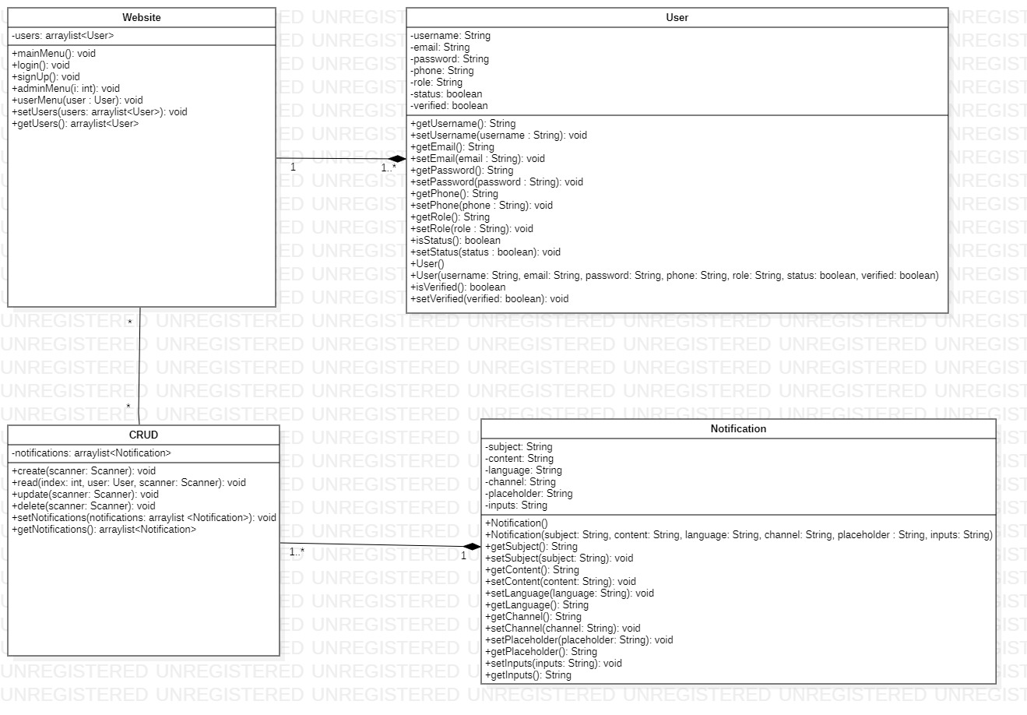

# 

# Sequence diagram designC:\Users\Hitler\Downloads\Blank diagram (3).jpeg

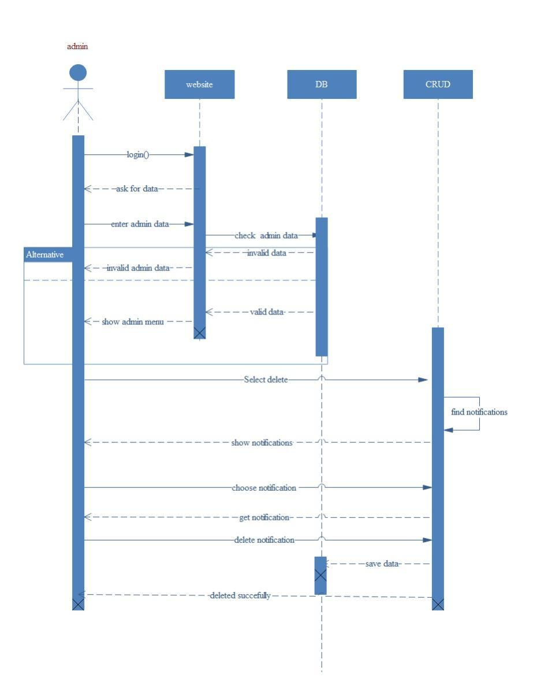

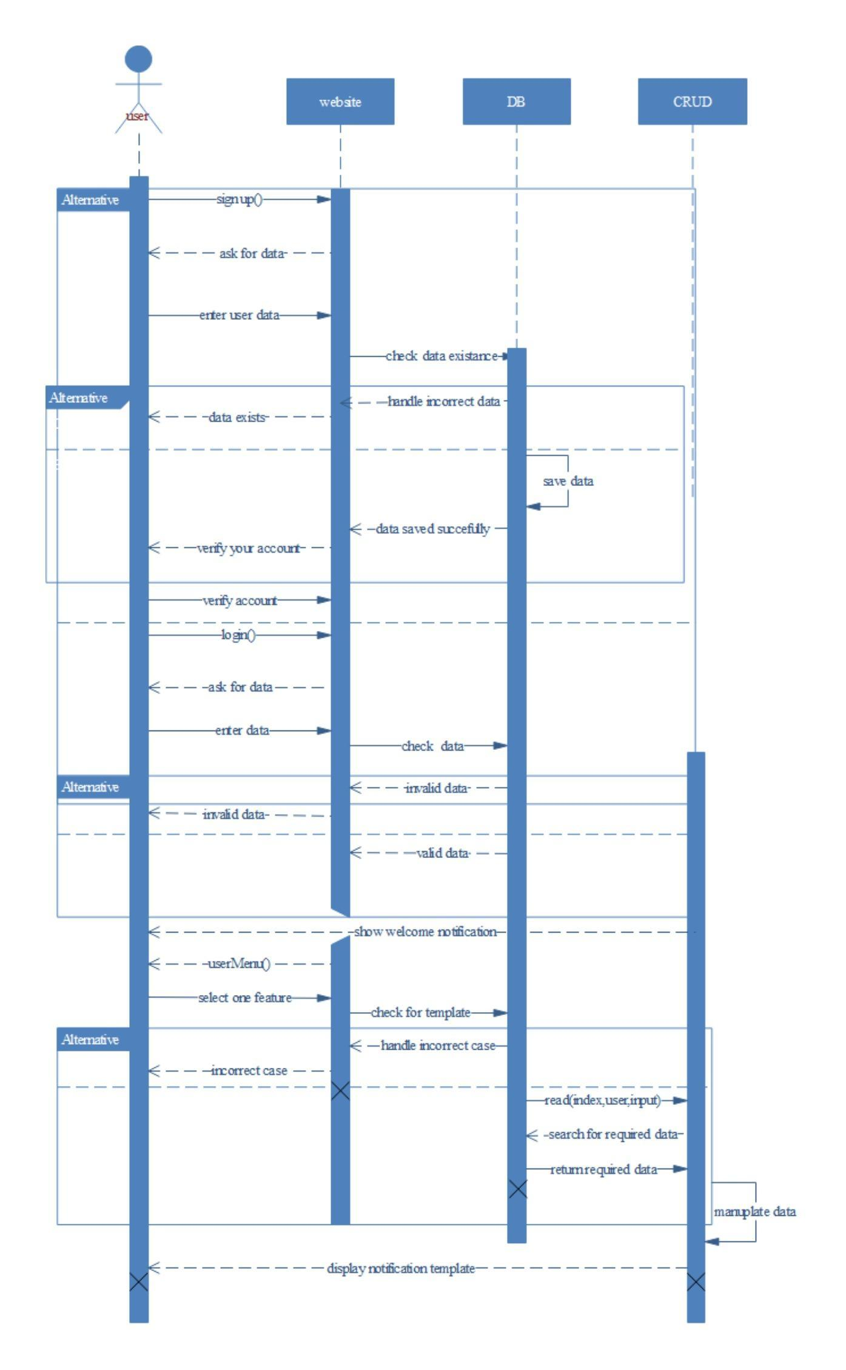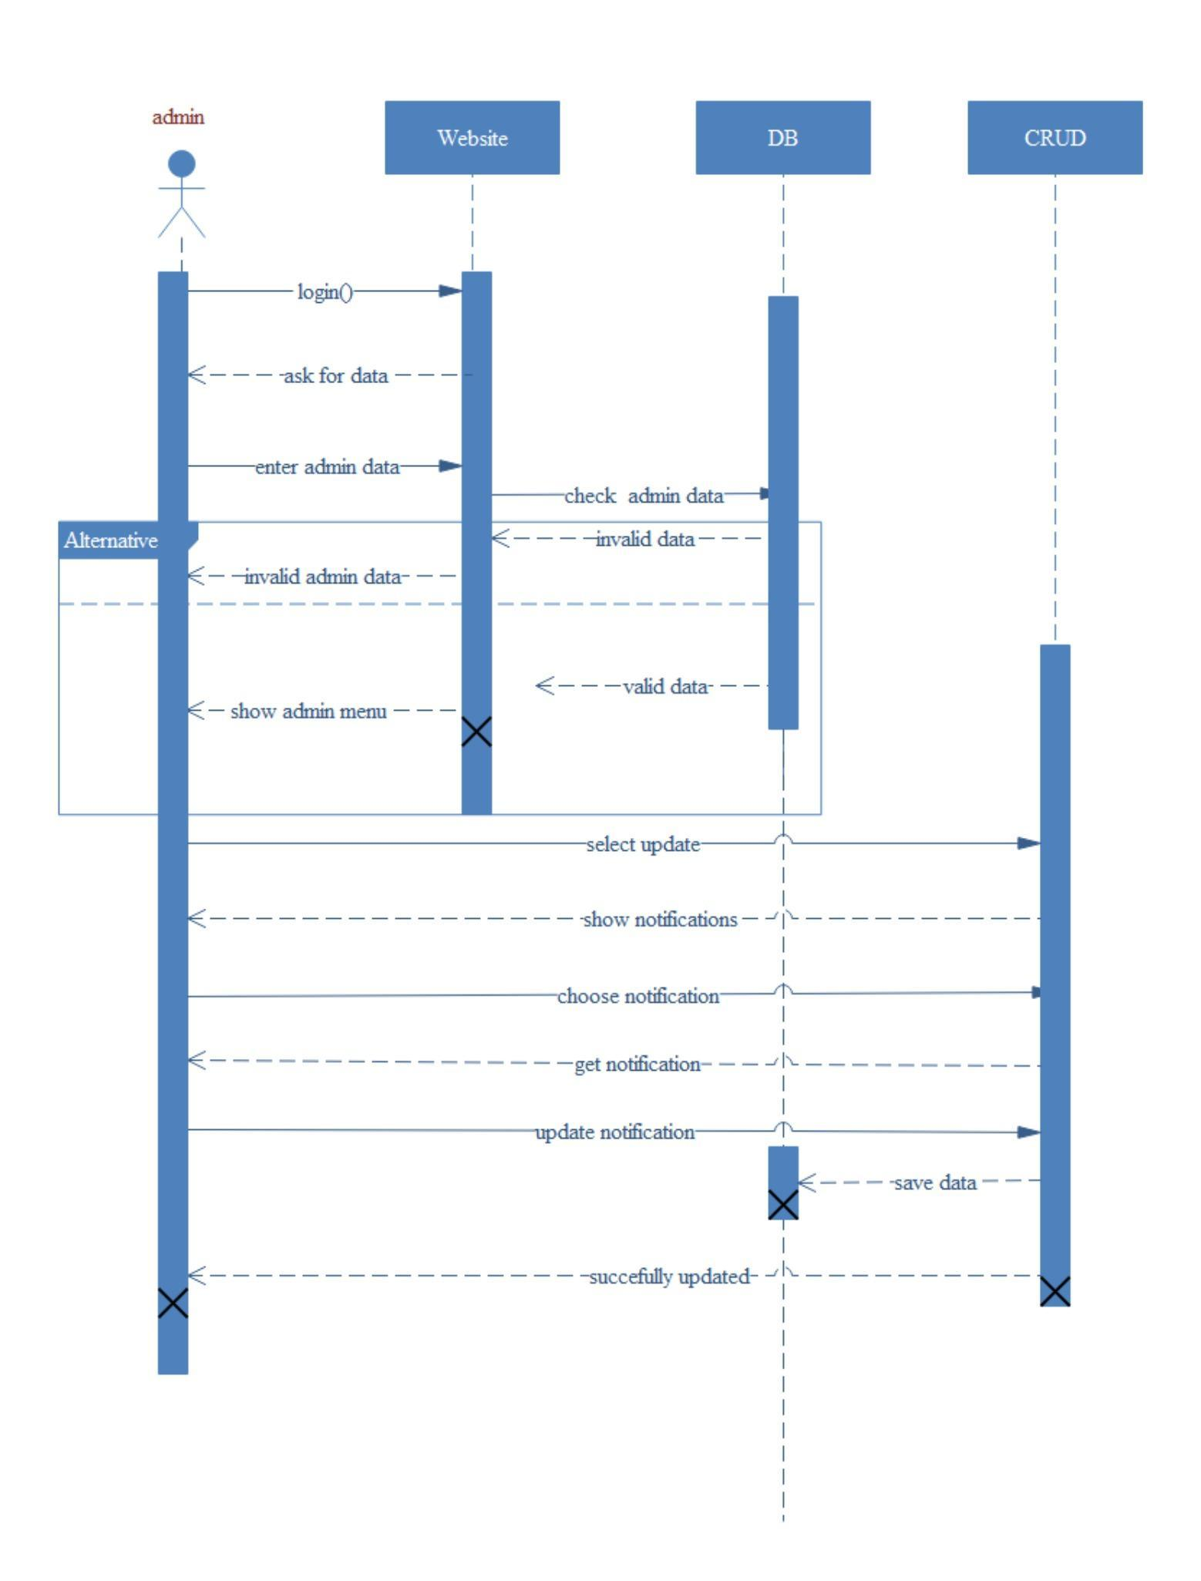

# Github repository link

### <https://github.com/TawfikYasser/Advanced-Software-Engineering-CS352>